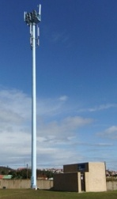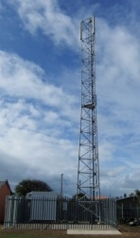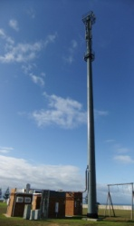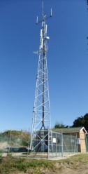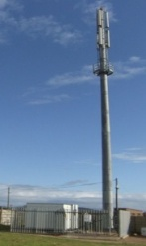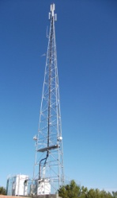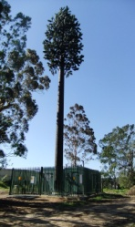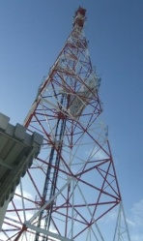
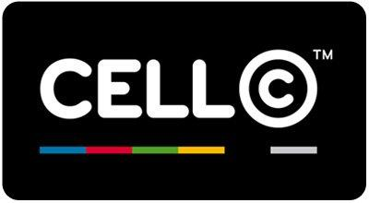
FANRA ELECTRICAL
CC

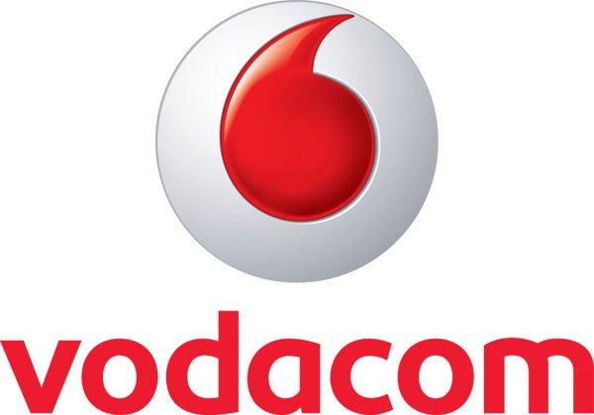


INTRODUCTION:
Is a company that installs, tests, commissions and maintains telecommunication networking solutions. We take great pride in our work, product knowledge, quality and ensure tidy and neat installations. It is the aim of our company to establish long term quality relationships with our clients that promote growth that further develop our mutual business success.

We provide unmatched top quality services to our clients. We are highly experienced and are well equipped to perform the required duties. We adapt to the needs of our clients and have a ‘Can Do’ attitude.

MISSION:
Working according to stringent safety and quality standards that are never compromised. These high standards combined with our commitment to service excellence are reflected in our work. We strive to be efficient and responsive and ensure that technical problems are resolved in the shortest possible time. Mykatrade have a ‘Can Do’ attitude and are flexible enough to grow and change with our customer base. We pride ourselves with proper equipment and technical knowledge to establish quality and professional relationships with our clients that promote future growth and mutual business success.

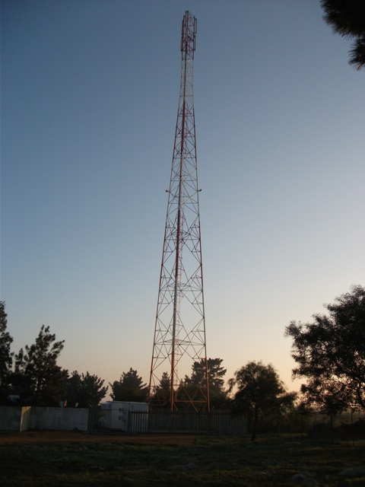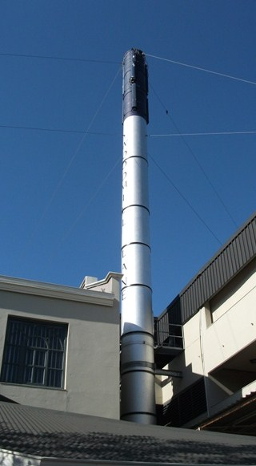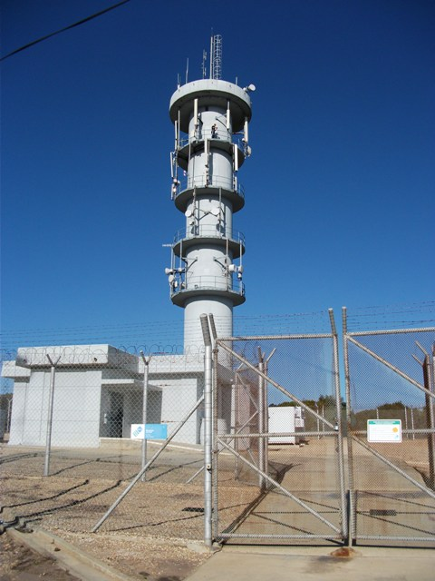

OBJECTIVES:
Continuously provide professional quality services on time and on budget. To provide top quality support and services we are constantly learning and are aware of technological changes in the market and ensure that we have the knowledge and expertise to deliver such services. We strive to do the related work right and on time the first time. We understand that downtime = lost revenue.

CUSTOMER SUPPORT:
We understand the importance of having sites fully operational. To provide efficient, responsive support, our support specialists ensure that technical problems are resolved in the shortest possible time by being on stand-by 24 hours a day 7 days a week. We strive to do the related work right and on time the first time. We understand that downtime = lost revenue. We are always available and have proven so in the past. We are committed to service excellence and are always on stand-by. With our vast equipment knowledge and experience we also offer technical support that is just a phone call away. We also carry enough spares and stock to sort problems fast and efficient.

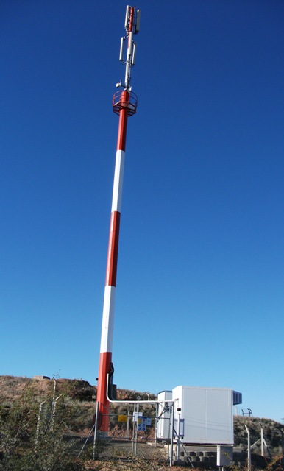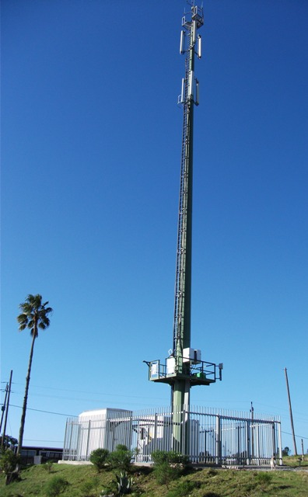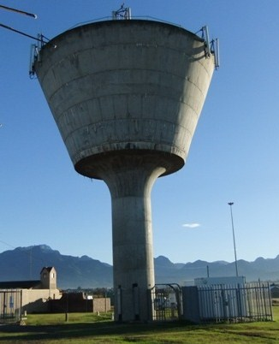

PROFILE:
Mykatrade is a technical company providing installation, commissioning & maintenance services solutions to companies that are in the GSM Radio and Telecommunication business. Although we have not traded for long as a new company we aim to provide unmatched top quality services to our clients. We are highly experienced and are well equipped to perform the required duties. We are growing from strength to strength and have a ‘Can Do’ attitude. Employed staff have performed work on GSM Networks in the following regions (but are not limited)
Limpopo, Mapumulanga, KZN, Free State, North West Province and the whole of Gauteng. Mykatrade also has good relationships with the following companies:
Tappans Electrical, Boniswa Corporate Solutions, Fanra Electrical cc, 5G Technical Services, ARP Refrigeration, Vodacom SA
Capabilities, Experience and Expertise:
We at Mykatrade are geared to provide you with A-Z service which includes, but is not limited to:
BTS Equipment installations and swops (BTS racks, Rectifiers, Alarm systems, Air conditioners, DC fans, Free air cooling systems, AC & DC Power Back up systems)
Fault finding of site failures
Mini Cell installations and commissioning
Container and Build on Site Installations
Pre-commissioning BTS, power, microwave and RF equipment
Final-commissioning BTS, power, microwave and RF equipment
Installation, Commissioning and Maintenance of Rectifiers
Installation, Commissioning and Maintenance of Alarm
Installation and Commissioning of internal Bmon monitoring systems.
Installation, Commissioning and Maintenance of BTS equipment as well as the upgrades thereof
Installation of transmission equipment, cables and testing of links
Installation or adding of circuit breakers to live systems to ensure no downtime
Supply and install of transmission cabinets, PDU’s and DC Power cables.
Procurement of GSM specific material, Communication Data Cables (Power, Switching, Transmission, Optic Fibre) and Electronic Components.
Final Site acceptances and handover to customer
Preventative and corrective maintenance - site calibration and equipment configurations, routine maintenance on equipment
Mobile site deployment and activation
Site Clean ups – Recover Redundant Equipment
Vandalism repairs

Mykatrade 546 (pty) LTD
Reg Nr. 2014/032351/07
54 DANN ROAD
ASTON MANOR
KEMPTON PARK
SOUTH AFRICA

1619

OFFICE: +27(0)83 3527849
EMAIL: Audrey@myka.co.za

STEVEN SHANNON
CELL: +27(0)61 626 8209
CELL: + 27(0)82 853 9520
EMAIL: Steven@myka.co.za

